Low Level Design

Amazon Sales Data Analysis



**DOCUMENT CONTROL**

|  |  |  |  |
| --- | --- | --- | --- |
| **VERSION** | **DATE** | **AUTHOR** | **COMMENTS** |
| 1.0 | 20/09/2022 | Sikha Pandey | Introduction and problem statement |
| 1.1 | 10/10/2022 | Sikha Pandey | Dataset information, Architecture Description |
| 1.2 | 16/10/2022 | Sikha Pandey | Final Revision |
|  |  |  |  |

**Contents**

## 1. Introduction……………………………………………………………………………………………………… 03

**1.1 What is Low-Level Design Document? ………………………………………………….. 03 1.2 Scope ………………………………………………………………………………………………………….…... 03**

## 2. Problem Statement ………………………………………………………………………… ……………… 04

## 3. Dataset Information ……………………………………………………………………………………… 04

**4. Architecture ……………………………………………………………………………………………….…… 05**

**4.1 Architecture Description …………………………………………………………………………… 05**

# 1. Introduction

**1.1 What is Low-Level design document?**

The goal of the LDD or Low-level design document (LLDD) is to give the internal logic design of the actual program code for the Amazon Sales Data Analysis dashboard. LDD describes the class diagrams with the methods and relations between classes and program specs. It describes the modules so that the programmer can directly code the program from the document.

## 1.2 Scope

Low-level design (LLD) is a component-level design process that follows a step-by-step refinement process. The process can be used for designing data structures, required software architecture, source code, and ultimately, performance algorithms. Overall, the data organization may be defined during requirement analysis and then refined during data design work.

**1.3 Project Introduction**

This is a project about Amazon Sales Management. The E-commerce industry seeks to attain competence by creating and sustaining a unique process to collect personal information about customers and their purchasing trends. The report critically evaluates how amazon use management information system to attain a competitive advantage through efficient management and information. The main purpose of this project is to analyze Amazon Sales Data to obtain meaningful information. To obtain that sales data is provided, which includes sales amount, list price, cost price, etc.

**2. Problem Statement**

Sales management has gained importance to meet increasing competition and the need for improved distribution methods to reduce costs and increase profits. Today, Sales management is the most important function in a commercial and business enterprise.

**3. Dataset Information**

## The dataset information listed are:-

Invoice Date: Day on which the invoice is generated.

Discount Amount: Total discount provided on any item.

Sales Amount: Total Sales Price of an item.

Sales Margin Amount(Profit): Sales Margin Amount is a difference of Sales Cost Amount and Sales Amount.

Sales Price: Sales Price of any particular Item.

List Price: The basic price of an item as published on the price list.

Sales Rep: A person who is in charge of selling the product or services for the company.

U/M: Unit of Measure.

CustKey: It is a unique number on the Invoice that is used to reference customer’s accounts.

**4. Architecture**

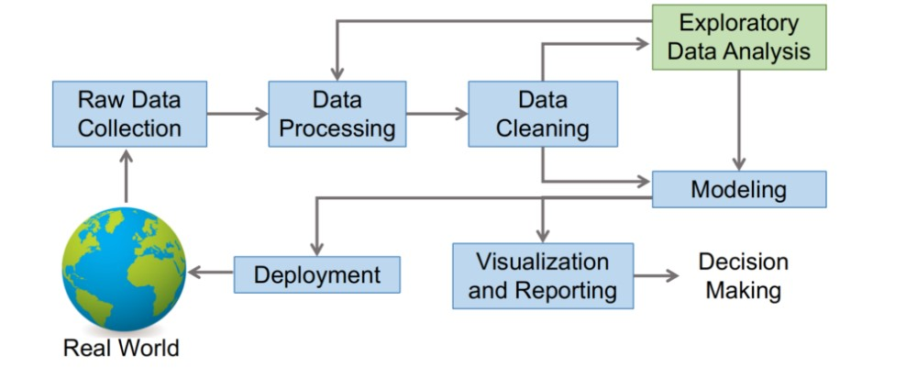

**4.1 Architecture Description**

**1. Raw Data Collection**

The dataset was provided in iNeuron’s Project Description Document.

https://drive.google.com/drive/folders/1FkmFVL8wlJmQWP1z52TD8PlhOJhitTyI?usp=s

haring

**2. Data Processing**

The first step is to process the data to feed the correct data to the model to learn and predict. The outcome will be dependent on the type of raw data feed.

This process includes:-

1. Handling missing /null values
2. Handling noisy data
3. Detecting Outliers and Removing them

**3. Data Cleaning**

Data cleaning is the process of detecting and correcting corrupt or inaccurate records from data-set and refers to identifying incomplete, incorrect, inaccurate, or irrelevant parts of the data and then replacing, modifying, or deleting the dirty or coarse data

**4. Exploratory Data Analysis (EDA)**

Exploratory Data Analysis refers to the critical process of performing initial investigations on data so as to discover patterns, spot anomalies, test hypotheses, and check assumptions with the help of summary statistics and graphical representation.

**5. Reporting**

Reporting is the most important and underrated skill of the data analytics field.

Because our data report can answer basic questions about the state of the business.

1. High-Level Design Document (HLD)
2. Low-Level Design Document (LLD)
3. Architecture
4. Wireframe
5. Detailed Project Report
6. Power Point Presentation

**6. Modelling**

Data modeling is the process of diagramming data flows. When creating a new or alternate database structure, the designer starts with a diagram of how data will flow into and out of the database.

**7. Deployment**

We created a Power BI Dashboard.

